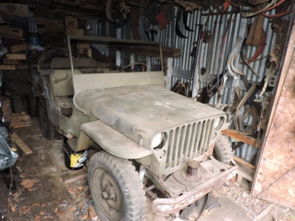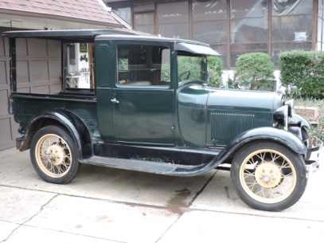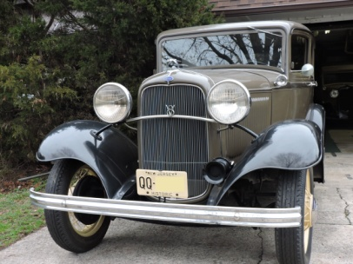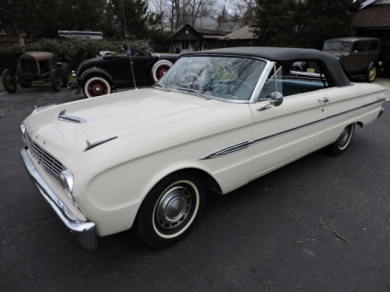

**ESTATE AUCTION**

**12 ANTIQUE CARS + 1,000's OF PARTS**

**SATURDAY, APRIL 9, 2016 @ 9 AM**

**LOCATION: Wamsley's Texaco Garage, 52 Harding Hwy (Rt 40), Pittsgrove, NJ 08318**

The legendary 50-yr collection of the estate of Mike Torowus.

1932 Ford V8 2-dr Sedan, 1928 Model A Pickup 82A, 1943 Ford Jeep, 1963 Ford Falcon, 1931 Panel Delivery 79B, 1930 Deluxe Phaeton 180A, 1931 Sedan Delivery 130B, 1931 Model A Sedan 160B, 1929 Model A Dump, Model A Rusty Relic, 1952 Crosley Super Sport, Old Ford Tractor, 1932 Ford V8 Engine, "A" Roadster tops (2), phaeton & roadster top mechanisms, "in box new" LeBaron Bonney "A" roadster seats/upholstery, engines, transmissions, radiator, body parts, 30 Model A motors, "T" parts, and much more.....

Bodies: 1931 Roadster Deluxe, 1930 Sport Coupe, 1930/1931 Truck Cab

**From the Estate of Joseph George:** 1955 Thunderbird, 1931 Model A Coupe-restored,

1971 Karmann Ghia convertible, 1935 Cadillac Sedan-needs restoring.

**All cars have titles!**

**Terms:** All items are sold "AS IS, WHERE IS," conditions unknown

Cash or local check with 2 IDs

Out of state checks must have bank letter of credit and 2 IDs.

**6% Buyers Premium**

**7% sales tax on car parts & accessories only.**

Contact Lee Fox Auctions for Absentee Bidding Terms & Conditions

**PREVIEW:** Friday, April 8, 2016 9am-4pm, or by appointment

**Lee M. Fox, Auctioneer 609-970-5163 email:** [**foxauctions@verizon.net**](mailto:FoxAuctions@verizon.net)

**See AuctionZip.com (ID #4959) for more information and photos**